Application
for the use of the
Wadden Sea World Heritage Logo
by a third party

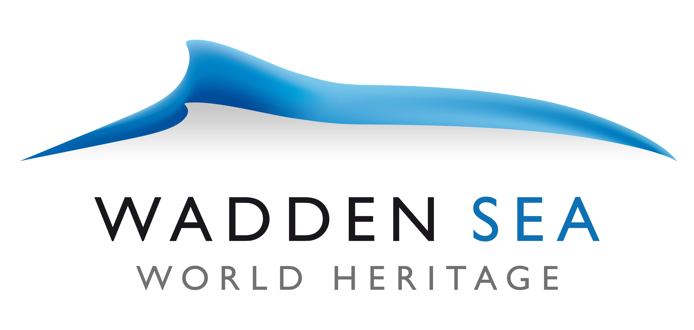

Common Wadden Sea Secretariat
Wilhelmshaven, August 2011

Applicant:
Name and organisation:
Address:
Phone:
Email:

Subject:

Date:

A. Explanation on the usage of teh Wadden Sea Logo
(max. 1 page, additional information can be attached in the annex)

- Short description of the product

- What are the aims of the product

- How does the product contributes to the values of the Wadden Sea World Heritage?

B. Criteria for the use of the WS-WH Logo

- Scoring scheme

0 = criteria not fulfilled, 1 = criteria just barely fulfilled, 2 = criteria fulfilled but not yet optimal, 3 = criteria completely fulfilled, n.a.=not applicable.

The logo can be used if a total score between 14 – 21 has been reached. None of the general requirements except the extraordinary contribution must be scored with 0.

The additional specific requirements will be assess as fulfilled or not, at least 4 of 5 requirements have to be fulfilled (n.a. = not applicable)

- General Requirements

Issue | Explanation (to be filled in by the applicant) | Scoring
- Authenticity: The offers of the applicants are authentic; they are original and unique. They build on the values of the World Heritage property and promote these values.

- Importance of nature and landscape: Natural or cultural elements are a central part of the offer.

- Mobility: Public transport is offered for the travel to the World Heritage property and experience of nature and culture in the World Heritage region. Incentives are created to support the use of public transport.
- Regional added value: The applicant contributes to achieve additional local and regional added value.
- Nature protection: Protection of nature and landscape is supported.
- Cooperation: Stakeholders from nature conservation, culture and economy as well as the local inhabitants cooperate in the elaboration and implementation of offers.

- Communication: The transnational World Heritage is communicated with attractive resources covering information about the region, nature, culture, landscape and the values of the World Heritage.

- Extraordinary contribution: The applicant creates an added value with an extraordinary contribution (foundation, sponsor) for the World Heritage

Total
 | Criteria fulfilled

- Additional specific requirements
(yes or no), n.a. = not applicable

Issue | Explanation | Scoring
- The licence partner actively distributes information material about the World Heritage.

- A product brochure which uses the World Heritage Logo must contain the following information: Importance and short description of the transnational World Heritage Site, general rules of conduct in the property, reference to specific World Heritage offers and products.

- An image brochure which uses the World Heritage Logo must contain the following information: Importance and short description of the transnational World Heritage Site.

- The logo is placed on the homepage of the licence partner with direct link to the official website www.waddensea-worldheritage.org (Dutch and German website address respectively)
- Information about the World Heritage and communication material will be positioned at a public prominent place.

- Overall Assessment

[Short assessment of the application]

- PROPOSAL

[Proposal on how to decide on the application]

ANNEX

[Information about the product to be given in an annex.]

